PHP CODING CONVENTION
FOR
RIDE SHARING WITH GPS
Version 1.0

Revision History
Date | Version | Description | Author | Approved
Apr-8-2015 | 1.0 | First creation | Terry
www.enclaveIT.com

Approver | Reviewer | Creator
Lieu (Lyn) T.B. TRAN | Hoang (Hanley) T. NGUYEN | Thanh (Terry) D. TRAN

Table of Contents

1. Introduction 4
1.1 Purpose 4
1.2 Application scope 4
1.3 Related documents 4
1.4 Definition 4
2. General Rules 5
2.1 PHP File Formatting 5
2.1.1 General 5
2.1.2 Indentation 5
2.1.3 Maximum Line Length 5
2.1.4 Line Termination 5
2.2 Naming Conventions 5
2.2.1 Single and Double Quotes 5
2.2.2 Indentation 5
2.2.3 Brace Style 6
2.2.4 Regular Expressions 7
2.2.5 No Shorthand PHP Tags 7
2.2.6 Remove Trailing Spaces 7
2.2.7 Space Usage 7
2.2.8 Formatting SQL statements 8
2.2.9 Database Queries 8
2.2.10 Naming Conventions 8
2.2.11 Self-Explanatory Flag Values for Function Arguments 9
2.2.12 Ternary Operator 9
2.2.13 Yoda Conditions 10
2.2.14 Clever Code 10
2.2.15 Error Control Operator @ 10
2.2.16 Don’t extract() 10

Introduction

Purpose
Code conventions are important to programmers for a number of reasons:
- 80% of the lifetime cost of a piece of software goes to maintenance.
- Hardly any software is maintained for its whole life by the original author.
- Code conventions improve the readability of the software, allowing engineers to understand new code more quickly and thoroughly.
If you ship your source code as a product, you need to make sure it is as well packaged and clean as any other product you create.

Application scope

Related documents
No. | Code | Name of documents
1 | Coding Standard for PHP | Zend Framework Coding Standard for PHP.  http://framework.zend.com

Definition
Terminology | Explanation

General Rules

PHP File Formatting

General
For files that contain only PHP code, the closing tag ("?>") is never permitted. It is not required by PHP, and omitting it´ prevents the accidental injection of trailing white space into the response.

Indentation
Indentation should consist of 4 spaces. Tabs are not allowed.

Maximum Line Length
The target line length is 80 characters. That is to say, PHP developers should strive keep each line of their code under 80 characters where possible and practical. However, longer lines are acceptable in some circumstances. The maximum length of any line of PHP code is 120 characters.

Line Termination
Line termination follows the Unix text file convention. Lines must end with a single linefeed (LF) character. Linefeed characters are represented as ordinal 10, or hexadecimal 0x0A.
Note: Do not use carriage returns (CR) as is the convention in Apple OS's (0x0D) or the carriage return - linefeed combination (CRLF) as is standard for the Windows OS (0x0D, 0x0A).

Naming Conventions

Single and Double Quotes
Use single and double quotes when appropriate. If you’re not evaluating anything in the string, use single quotes. You should almost never have to escape quotes in a string, because you can just alternate your quoting style, like so:
Text that goes into attributes should be run through esc_attr() so that single or double quotes do not end the attribute value and invalidate the HTML and cause a security issue. See Data Validation in the Codex for further details.

Indentation
Your indentation should always reflect logical structure. Use real tabs and not spaces, as this allows the most flexibility across clients.
Exception: if you have a block of code that would be more readable if things are aligned, use spaces:
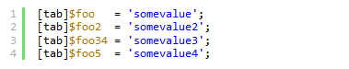
For associative arrays, values should start on a new line. Note the comma after the last array item: this is recommended because it makes it easier to change the order of the array, and makes for cleaner diffs when new items are added.
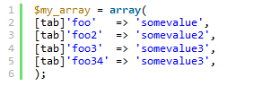
Rule of thumb: Tabs should be used at the beginning of the line for indentation, while spaces can be used mid-line for alignment.

Brace Style
Braces shall be used for all blocks in the style shown here:
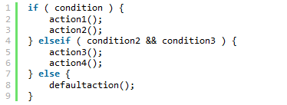
Furthermore, if you have a really long block, consider whether it can be broken into two or more shorter blocks or functions. If you consider such a long block unavoidable, please put a short comment at the end so people can tell at glance what that ending brace ends – typically this is appropriate for a logic block, longer than about 35 rows, but any code that’s not intuitively obvious can be commented.
Braces should always be used, even when they are not required:
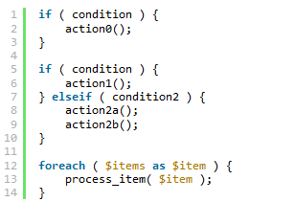
Note that requiring the use of braces just means that single-statement inline control structures are prohibited. You are free to use the alternative syntax for control structures (e.g. if/endif, while/endwhile)—especially in your templates where PHP code is embedded within HTML, for instance:
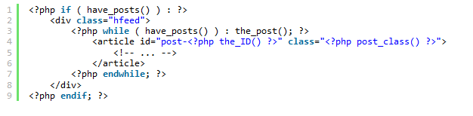

Regular Expressions
Perl compatible regular expressions (PCRE, preg_ functions) should be used in preference to their POSIX counterparts. Never use the /e switch, use preg_replace_callback instead.
It’s most convenient to use single-quoted strings for regular expressions since, contrary to double-quoted strings, they have only two metasequences: \' and \\.

No Shorthand PHP Tags
Important: Never use shorthand PHP start tags. Always use full PHP tags.
Correct:
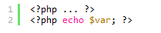
Incorrect


Remove Trailing Spaces
Remove trailing whitespace at the end of each line of code. Omitting the closing PHP tag at the end of a file is preferred. If you use the tag, make sure you remove trailing whitespace.

Space Usage
Always put spaces after commas, and on both sides of logical, comparison, string and assignment operators.
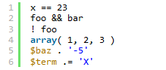
Put spaces on both sides of the opening and closing parenthesis of if, elseif, foreach, for, and switch blocks.
When defining a function, do it like so:
When calling a function, do it like so:
When performing logical comparisons, do it like so:
When type casting, do it like so:
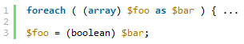
When referring to array items, only include a space around the index if it is a variable, for example:
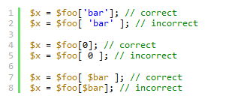

Formatting SQL statements
When formatting SQL statements you may break it into several lines and indent if it is sufficiently complex to warrant it. Most statements work well as one line though. Always capitalize the SQL parts of the statement like UPDATE or WHERE.
Functions that update the database should expect their parameters to lack SQL slash escaping when passed. Escaping should be done as close to the time of the query as possible, preferably by using $wpdb->prepare().
$wpdb->prepare() is a method that handles escaping, quoting, and int-casting for SQL queries. It uses a subset of the sprintf() style of formatting. Example :
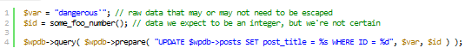

Database Queries
Avoid touching the database directly. If there is a defined function that can get the data you need, use it. Database abstraction (using functions instead of queries) helps keep your code forward-compatible and, in cases where results are cached in memory, it can be many times faster.
If you must touch the database, get in touch with some developers by posting a message to the wp-hackers mailing list. They may want to consider creating a function for the next WordPress version to cover the functionality you wanted.

Naming Conventions
Use lowercase letters in variable, action, and function names (never camelCase). Separate words via underscores. Don’t abbreviate variable names un-necessarily; let the code be unambiguous and self-documenting.
Class names should use capitalized words separated by underscores. Any acronyms should be all upper case.
Constants should be in all upper-case with underscores separating words:
Files should be named descriptively using lowercase letters. Hyphens should separate words.
Class file names should be based on the class name with class- prepended and the underscores in the class name replaced with hyphens, for example WP_Error becomes:
This file-naming standard is for all current and new files with classes. There is one exception for three files that contain code that got ported into BackPress: class.wp-dependencies.php, class.wp-scripts.php, class.wp-styles.php. Those files are prepended with class., a dot after the word class instead of a hyphen.
Files containing template tags in wp-includes should have -template appended to the end of the name so that they are obvious.

Self-Explanatory Flag Values for Function Arguments
Prefer string values to just true and false when calling functions.
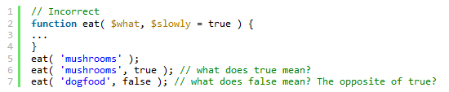
Since PHP doesn’t support named arguments, the values of the flags are meaningless, and each time we come across a function call like the examples above, we have to search for the function definition. The code can be made more readable by using descriptive string values, instead of booleans.
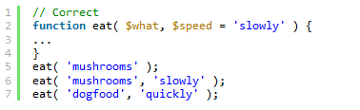

Ternary Operator
Ternary operators are fine, but always have them test if the statement is true, not false. Otherwise, it just gets confusing. (An exception would be using !empty(), as testing for false here is generally more intuitive.)

For example:
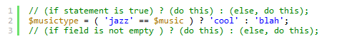

Yoda Conditions
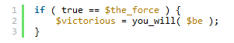
When doing logical comparisons, always put the variable on the right side, constants or literals on the left.
In the above example, if you omit an equals sign (admit it, it happens even to the most seasoned of us), you’ll get a parse error, because you can’t assign to a constant like true. If the statement were the other way around ($the_force = true), the assignment would be perfectly valid, returning 1, causing the if statement to evaluate to true, and you could be chasing that bug for a while.
A little bizarre, it is, to read. Get used to it, you will.
This applies to ==, !=, ===, and !==. Yoda conditions for <, >, <= or >= are significantly more difficult to read and are best avoided.

Clever Code
In general, readability is more important than cleverness or brevity.
Although the above line is clever, it takes a while to grok if you’re not familiar with it. So, just write it like this:
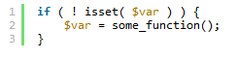

Error Control Operator @
As noted in the PHP docs:
PHP supports one error control operator: the at sign (@). When prepended to an expression in PHP, any error messages that might be generated by that expression will be ignored.
While this operator does exist in Core, it is often used lazily instead of doing proper error checking. Its use is highly discouraged, as even the PHP docs also state:
Warning: Currently the “@” error-control operator prefix will even disable error reporting for critical errors that will terminate script execution. Among other things, this means that if you use “@” to suppress errors from a certain function and either it isn’t available or has been mistyped, the script will die right there with no indication as to why.

Don’t extract()
The extract() is a terrible function that makes code harder to debug and harder to understand. We should discourage it’s use and remove all of our uses of it.

